Indian Sign Language Translator

Rahul Pareek  
Department of Computer Science  
Arya College of Engineering & I.TJaipur, India  
[rahulpareek9250@gmail.com](mailto:rahulpareek9250@gmail.com)

Yuvraj Gupta  
Department of Computer Science  
Arya College of Engineering & I.TJaipur, India  
[guptayuvraj2002@gmail.com](mailto:guptayuvraj2002@gmail.com)

Rushikesh Bodke  
Department of Computer Science  
Arya College of Engineering & I.TJaipur, India  
[rishi6sep@gmail.com](mailto:radhesaini288@gmail.com)

Suraj Dhara  
Department of Computer Science  
Arya College of Engineering & I.T Jaipur, India  
[dsuraj32@gmail.com](mailto:dsuraj32@gmail.com)

***Abstract -*** Deaf people always miss out the fun that a normal person does, may it be communication, playing computer games, attending seminars or video conferences, etc. Communication is the most important difficulty they face with normal people and also every normal person does not know the sign language. The aim of our project is to develop a communication system for the deaf people. It converts the audio message into the sign language. This system takes audio as input, converts this audio recording message into text and displays the relevant Indian Sign Language images or GIFs which are predefined. By using this system, the communication between normal and deaf people gets easier.

***Keywords—*** speech-recognition, speech-to-text, machine- translation, natural-language-processing, python3.

**Introduction**

It is said that Sign language is the mother language of deaf people. This includes the combination of hand movements, arms or body and facial expressions. There are 135 types of sign languages all over the world. Some of them are American Sign Language (ASL), Indian Sign Language (ISL), British Sign Language (BSL), Australian Sign Language (Auslan) and many more. We are using **Indian Sign Language** in this project. This system allows the deaf community to enjoy all sort of things that normal people do from daily interaction to accessing the information.

This application takes speech as input, converts it into text and then displays the Indian Sign Language images.

* The front end of the system is designed using EasyGui.
* Speech which is taken as input through microphone uses PyAudio package.
* The speech is recognized using Google Speech API.

nThe text is then pre-processed using NLP (Natural Language Processing).

* Finally, Dictionary based machine translation is done.

Sign language is communication language used by the deaf peoples using face, hands or eyes while using vocal tract. Sign language recognizer tool is used for recognizing sign language of deaf and dumb people. Gesture recognition is an important topic due to the fact that segmenting a foreground object from a cluttered background is a challenging problem.

There is a difference when human looks at an image and a computer looking at an image. For Humans it is easier to ﬁnd out what is in an image but not for a computer. It is because of this, computer vision problems remain a challenge.

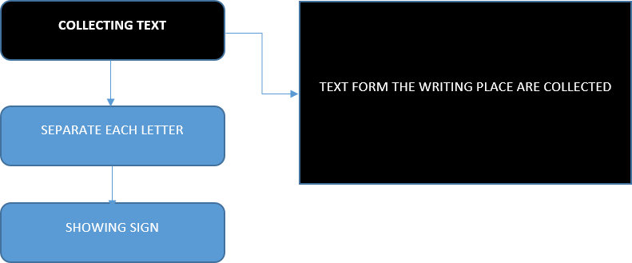Fig. 1 (a): Block diagram of Text Collection

Fig.1 (a) shows how it takes it takes audio as input and search that audio recording is recognized using google speech API.

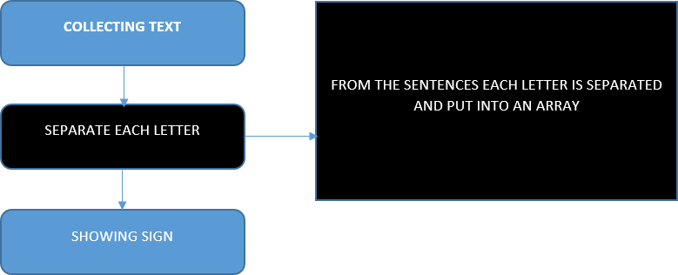Fig. 1 (b): Block diagram of Text Separation

Fig. 1(b) shows the sentence or word recognized through audio input is separated into single letter and then put into an array.

Fig. 1(c) shows that after separating the text a set

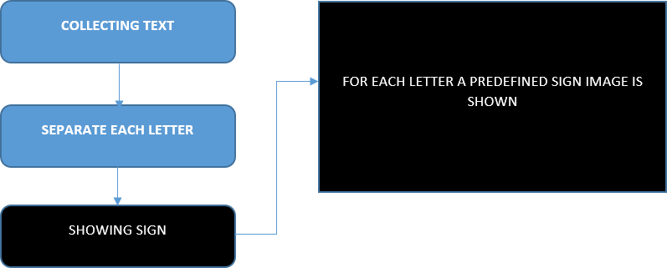Fig. 1(c): Block diagram of Sign Language conversion

Fig.2 shows the predefined signs used in this project. As per the audio input given it shows sign code.

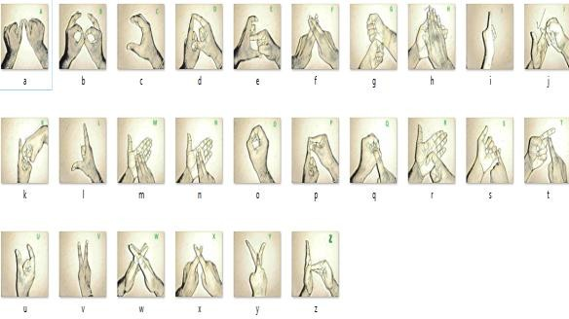Fig.2: Predefined signs

Lexical selection is done-

* **English** “I had dinner with Sita”

**ISL** “I SITA WITH NIGHT FOOD FINISH”

Subject-Object Verb (SOV) pattern is preferred by ISL.

* **English** “I have a computer”

**ISL** “I COMPUTER HAVE”.

However, the order of words depends upon the verb and its direction as below.

1. **English** “I help you”

**ISL** “SelfHELP Front”

**LITERATURE SURVEY**

1. As per Amit Kumar Shinde on his study of sign language to text and vice versa in Marathi Sign language recognition is one of the most important research and it is the most natural and common way of communication for the people with hearing problems. A hand gesture recognition system can help deaf persons to communicate with normal people in the absence of an interpreter. The system works both in offline mode and through web camera.
2. Neha Poddar, Shrushti Rao, Shruti Sawant, Vrushali Somavanshi, Prof. Sumita Chandak in their paper discussed about the prevalence of deafness in India is fairly significant as it is the second most common cause of disability. A portable interpreting device which convert higher mathematics sign language into corresponding text and voice can be very useful for the deaf people and solve many difficulties.

**PROPOSED WORK**

Our objective is to help people suffering from the problem of hearing. There have been many projects done on the sign languages that convert sign language as input to text or audio as output. But audio to sign language conversion systems have been rarely developed. It is useful to both normal and deaf people. In this project we introduce new technology that is audio to sign language translator using python. In this it takes audio as input, search that recording using google api, display the text on screen and finally it gives sign code of given input using ISL (Indian Sign Language) generator. All the words in the sentence are then checked against the words in the dictionary containing images and GIFs representing the words. If the words are not found, its corresponding synonym is replaced. Set of gestures are predefined in the system.

### **Procedure**

1. **Audio to Text Conversion:**

* Audio input is taken using python PyAudio module.
* Conversion of audio to text using microphone
* Dependency parser is used for analyzing grammar of the sentence and obtaining relationship between words.

1. **Text to Sign Language:**

* Speech recognition using Google Speech API.
* Text Preprocessing using NLP.
* Dictionary based Machine Translation.
* ISL Generator: ISL of input sentence using ISL grammar rules.
* Generation of Sign language with signing Avatar.

**IMPLEMENTATION AND RESULTS**

Output Generation

Output for a given English text is produced by generating its equivalent sign language depiction.

The output of this system will be a clip of ISL words. The predefined database will be having video for each and every separate words and the output video will be a merged video of such words.

1. **Fig. 3 shows the front end of the system is designed using EasyGui.**

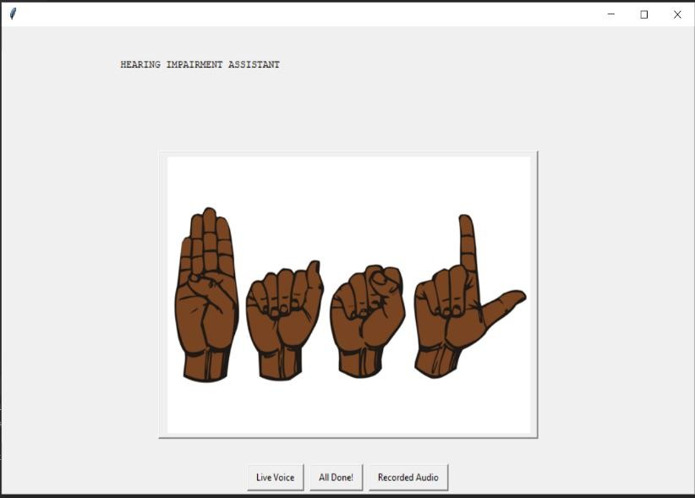Fig.3: Front end

1. **Fig.4 shows speech which is taken as input through microphone uses PyAudio package.**

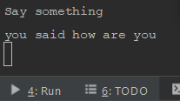Fig.4: Speech Input

1. **Fig. 5 shows the speech is recognized using Google Speech API.**

Google Speech-to-Text feature converts audio to text by applying neural network models in an easy-to-use API.

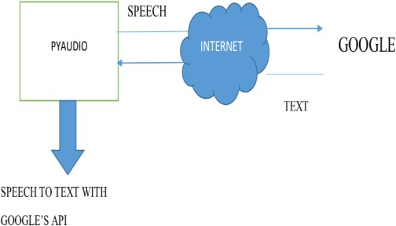Fig.5: Google Speech-to-text

**4). The text is then pre-processed using NLP (Natural Language Processing).**  
As we know that Machine can only understand binary language (i.e.0 and 1) then how can it understand our language. So, to make the machine understand human language NLP was introduced.

Natural Language Processing is the ability of the machine where it processes the text said and structures it. It understands the meaning of the words said and accordingly produces the output.

Text preprocessing consists of three things- Tokenization, Normalization and Noise removal as shown in Fig.6.

Natural Language processing which is the mixture of artificial intelligence and computational linguistics. But actually how it works with our project is most important. NLP can do additional functions to our language. We will get our information after giving audio input based on the NLP devices to understand human language. For example, Cortana and Siri.

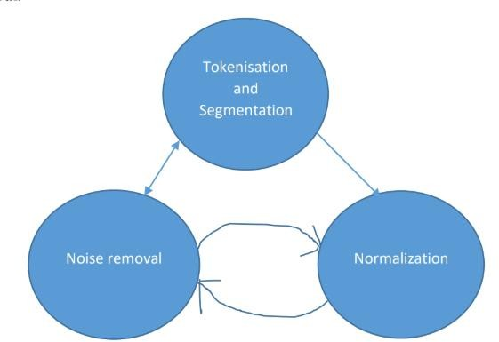Fig.6: Text pre-possessing

It is not an easy task for the machine to understand our language but with the help of NLP, it becomes possible. Actually how it works is shown below:

* We give audio as input to the machine.
* The machine records that audio input.
* Then machine translates the audio into text and displays it on the screen.
* The NLP system parses the text into components; understand the context of the conversation and the intention of the person.
* The machine decides which command to be executed, based on the results of NLP.

Actually NLP is process of creating algorithm that translates text into word labelling them based on the position and function of the words in the sentences.

Human language is converted meaningfully into a numerical form. This allows computers to understand the nuances implicitly encoded into our language.

1. **Dictionary based machine translation is done finally.**

When you speak “How Are You” as input into the microphone, the following output pops up as separate letters-

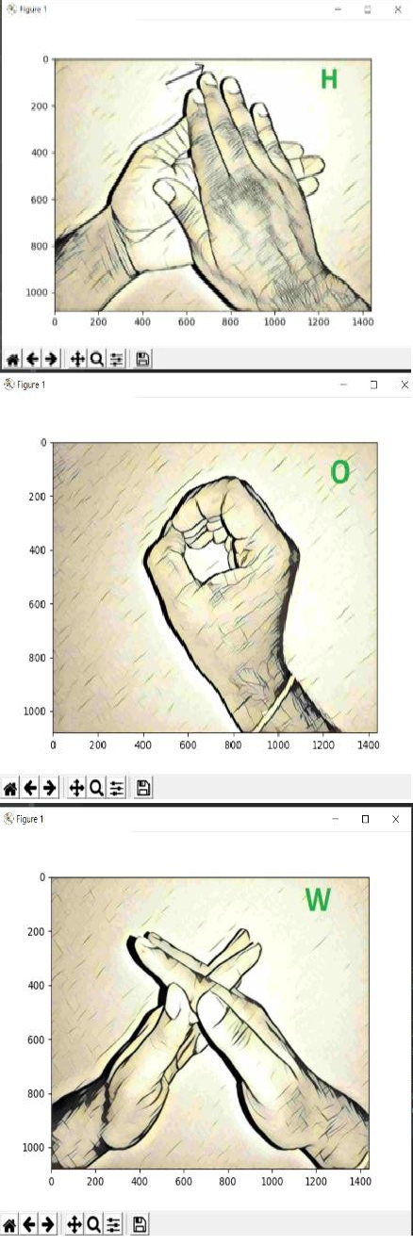Fig.7.1: Output sign (HOW)

Fig.7.2: Output signs (ARE)

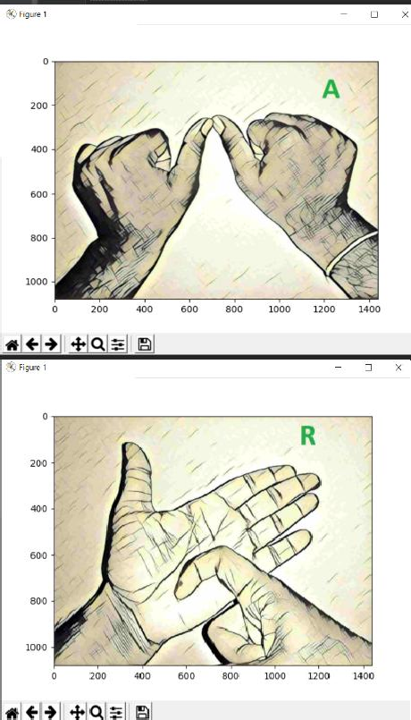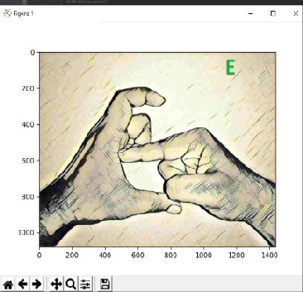

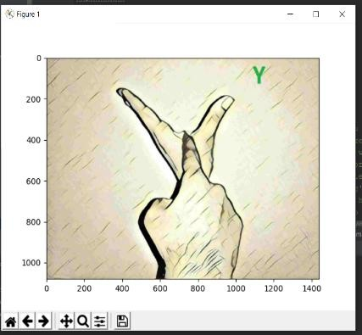

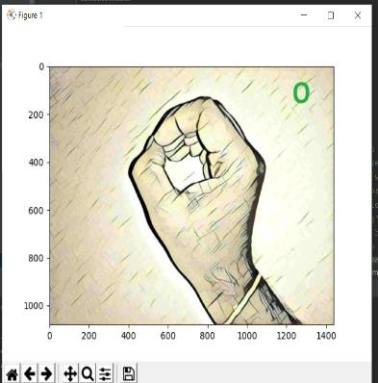

Fig.7.3: Output signs (YOU)

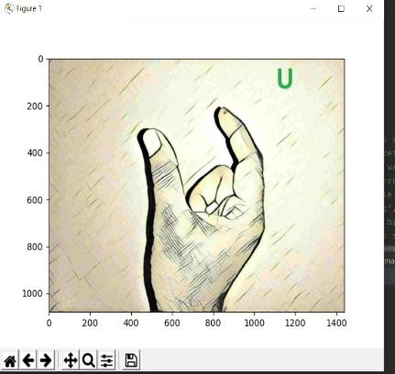

## **Abbreviations and Acronyms**

NLP - Natural Language Processing

NLU - Natural Language Understanding

NLG - Natural Language Generation

AI - Artificial Intelligence

ML - Machine Learning

CG - Computer Graphics

GIF- Graphics Interchange Format

**Market Research**

A web survey was used to collect data for this study, specifically participants comprising 50 potential users. The study was targeted to potential users of the sign language translator app who wanted to communicate with impaired people or learn sign language. To develop the web survey and make the most of this method, the study followed recommendations by Illum et al. (2010), such as keeping it short and guaranteeing the anonymity of participants.

Specifically, all participants were invited to read a general description regarding the Indian Sign Language Translator application.

Study showed below results

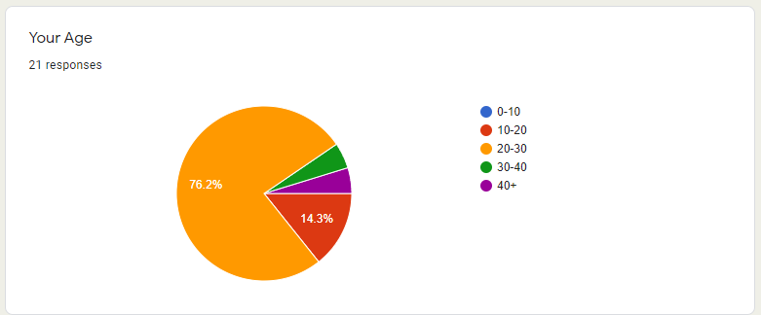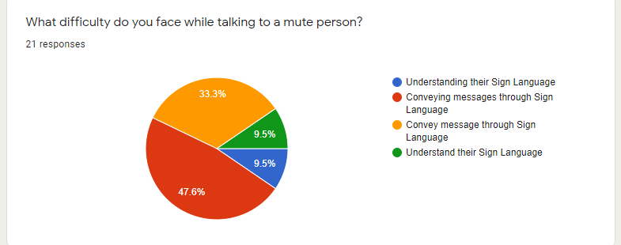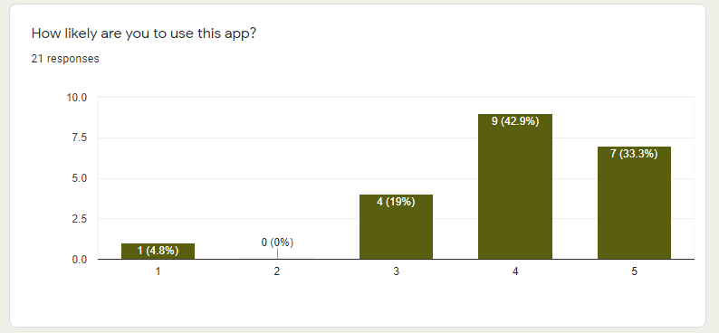

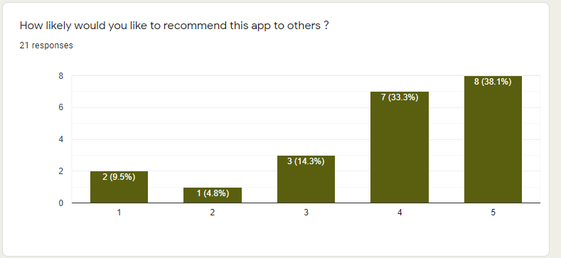

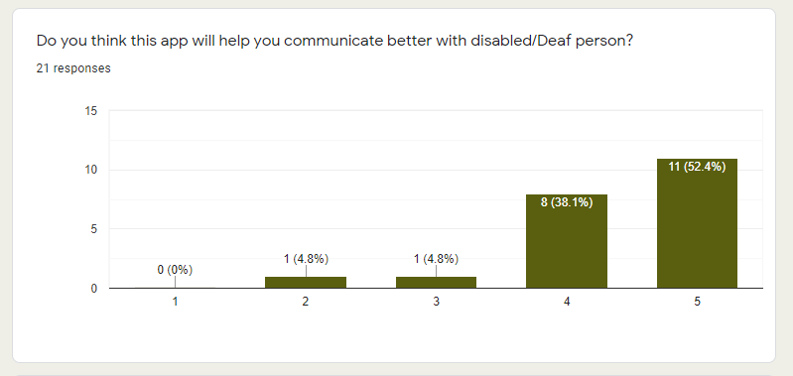

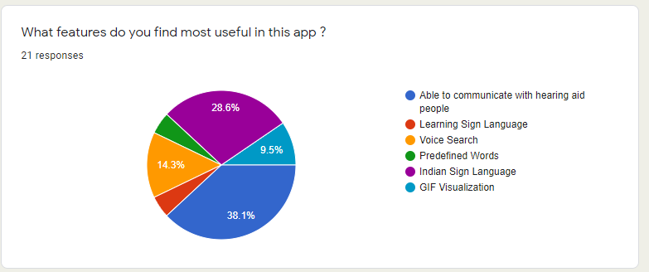Fig. 8 shows survey results

According to Survey we found out:

1. **85.2 %** of people loved the idea of the product and they would give it a try.
2. **70%** of people had difficulties communicating with impaired people.
3. **47.8%** of people had difficulties conveying their messages to impaired people.
4. **70.3%** of people were willing to use the application in order to communicate with impaired people.
5. **80.4%** people believe that this application will help them communicate with impaired people.
6. ~**70%** would recommend the application to other people.

**CONCLUSION AND FUTURE SCOPE**

Sign language translator is very useful in various areas. In schools, colleges, hospitals, universities, airports, courts anywhere anyone can use this system for understanding the sign language to communicate. It makes communication between a normal hearing person and a hard to hearing person easier. The future work is to develop an application where in the news channels can use it while giving news, in one corner of the screen it will be displayed in sign language for deaf people. Write now only DD news is using this kind of presentation but they are using a human being showing signs according to the speech of the person giving news live. So this will be better idea which we can give to news channels. We look forward to expand the project by also including facial expressions into the system.

**REFERENCES**

[1] Amit Kumar Shinde and Ramesh Khagalkar “sign language to text and vice versa recognization using computer vision in Marathi” International journal of computer Application (0975-8887) National conference on advanced on computing (NCAC 2015).

[2] Neha Poddar, Shrushti Rao, Shruti Sawant, Vrushali Somavanshi, Prof.Sumita Chandak "Study of Sign Language Translation using Gesture Recognition" International Journal of Advanced Research in Computer and Communication Engineering Vol. 4, Issue 2, February 2015.

[3]https://www.slideshare.net/mobile/madhuriyellapu/signlanguage-translator-ieee-power-point